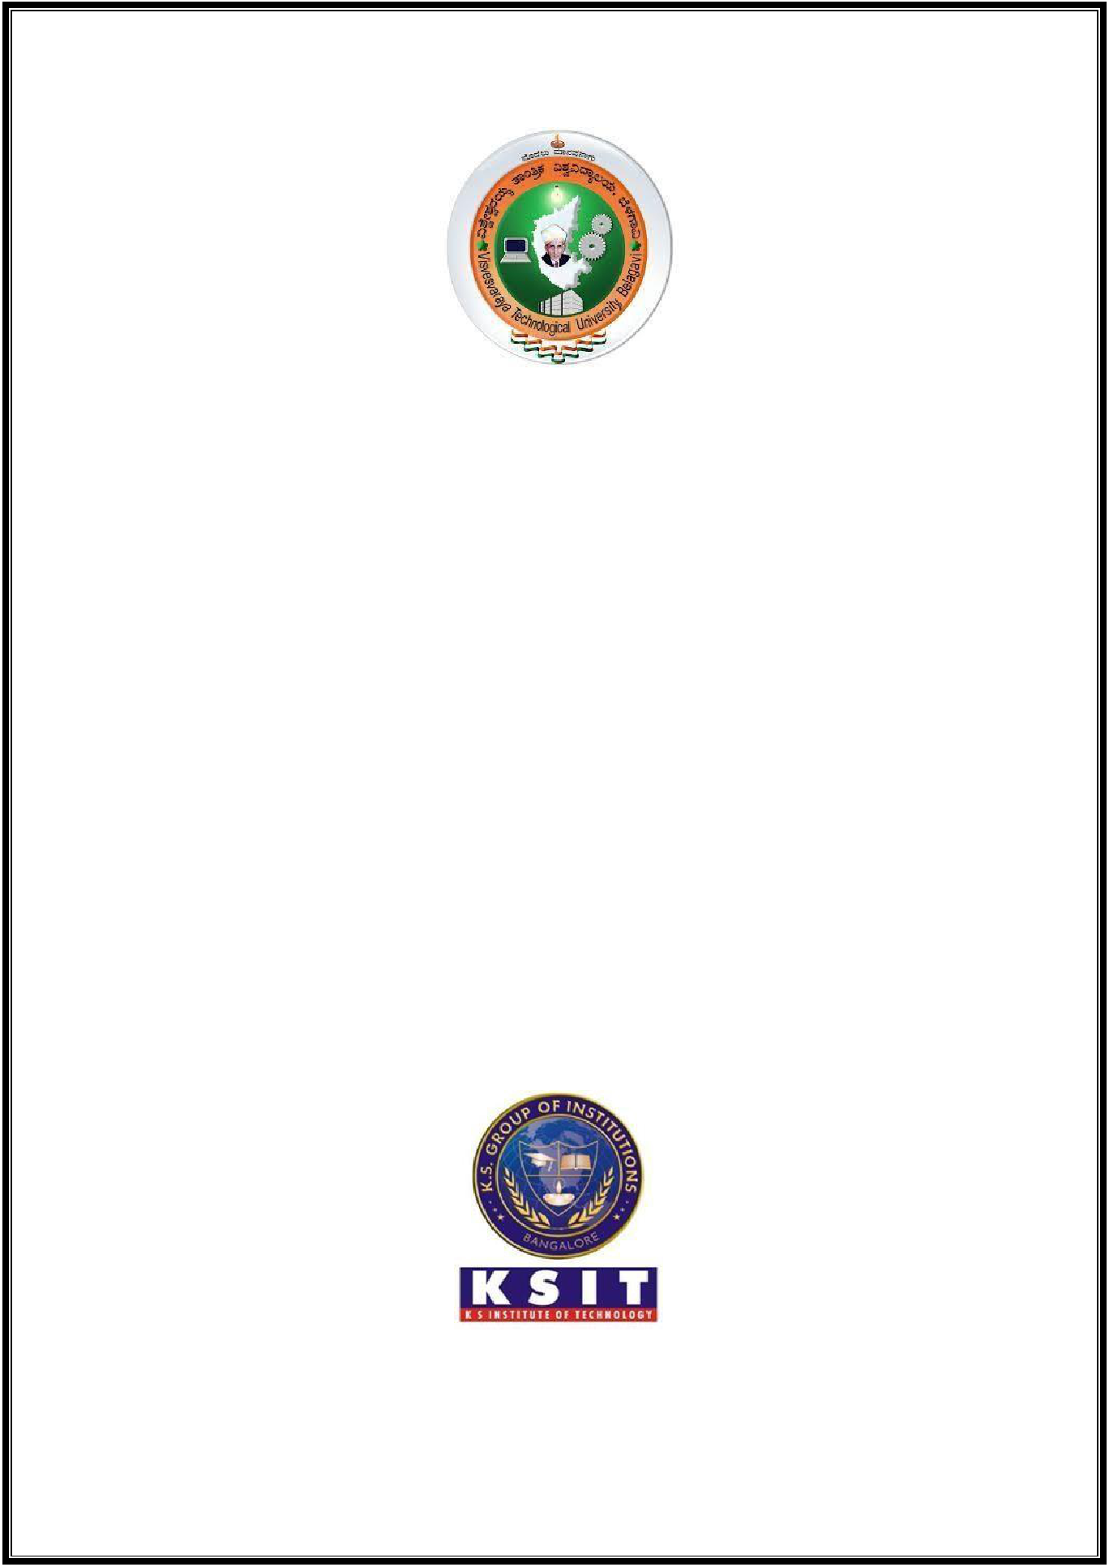**VISVESVARAYA TECHNOLOGICAL UNIVERSITY**

**“Jnana Sangama”, Belagavi-590018**

**A MINI PROJECT REPORT**

**ON**

**CONVERTER APP**

Submitted in partial fulfilment of the requirements

For the award of degree of

**Bachelor of Engineering**

**In**

**COMPUTER SCIENCE AND ENGINEERING**

Submitted by

**YASHWANTH K [1KS18CS121]**

**VINOD H MALALI [1KS18CS118]**

**PRATEEK HAVALE [1KS18CS070]**

Under the guidance of

**Mr. HARSHAVARDAN J R** **Mrs. BEENA K**

**Prof, CS&E Department** **Asst.prof, CS&E Department**

**Department of Computer Science & Engineering**

**K.S. INSTITUTE OF TECHNOLOGY**

#14, Raghuvanahalli, Kanakapura Road, Bengaluru- 560109

**2020-2021**